

**Green University of Bangladesh**

**Department of Computer Science and Engineering (CSE)**

**Faculty of Sciences and Engineering**

**Semester: (Fall, Year: 2022), B.Sc. in CSE (Day)**

**Course Title: Object Oriented Programming Lab**

**Course Code: CSE-202 Section: DA**

**Lab Project Name: Restaurant Management System**

**Student Details**

|  |  |  |
| --- | --- | --- |
| **Name** | | **ID** |
|  | **Md. Sohanur Rahman** | **213902106** |

**Submission Date : January 6, 2022**

**Course Teacher’s Name : Dr. Muhammad Aminur Rahaman**

**[For Teachers use only: Don’t Write Anything inside this box]**

|  |
| --- |
| **Lab Report Status**  **Marks: ………………………………… Signature:.....................**  **Comments:.............................................. Date:..............................** |

**Chapter 1**

**Introduction**

* 1. **Introduction**

**Restaurant Management system:**

This restaurant management system can be used by employees in a restaurant to handle the clients, their orders and can help them easily find free tables. The restaurant menu is organized by categories (appetizers, soups, salads, entrees, sides and drinks) of menu items. Each menu item has a name, price and associated recipe. A recipe for a menu item has a chef, preparation instructions and associated in gredients. Restaurant management system is the system for manage the restaurant business. Restaurant management can vary across multiple management styles, however, there is always one common

de-nominator when it comes to setting goals: maximizing a restaurant’s profitability. In order to maximize a restaurant’s profitability, one has to always examine and understand a restaurant’s operational costs and how these relate to a restaurant’s productivity and efficiency in delivering

quality service to its customers. Management takes a very important role in controlling and manipulating the balance of costs and profitability. An effective manager must always concern himself/herself with restaurant issues that pertain to inventory/stocking, pricing, order-taking, and

much more. Oftentimes, a restaurant’s profitability either

rises or falls depending on how well it is being managed. Managing a restaurant using a well-developed software minimizes the liabilities of mismanagement and productivity loopholes. The incorporation of a Restaurant Management Software in the managing of various business processes entails that your restaurant is competitive, innovative, well-managed, and up-to-date with the latest management and business trends.

* 1. **Objective**

The main objective is to maximize the profit by increasing efficient and decreasing the mistakes that takes place in the kitchen, this will be done without compromising customer satisfaction. At this moment of time, there are still numerous restaurants that still use paper based system to get messages across between the restaurant and the kitchen, this way of communication is one of the least efficient method. However, this approach may be implemented and designed in a successful profitable restaurant but there are numerous problems which might be seen as reducing therestaurants efficiency, they are the following:

* The lack of communication that is caused by handwriting.
* Uncontrolled order logging (poor order taking).
* Unproductive communication between restaurant and kitchen.
* Faults with order taking and lack of time management.
* Lack of good quality stock management.

Limited statistical output. So, in order to overcome these problems, we have made an application that is restaurant management system that mainly focuses on the above given problems. We have tried to build a user-friendly interface

**Chapter 2**

**Implementation of the Project**

**2.1 Process Model to be use with THEREASON:**

The process model we have used here is iterative model. The iterative model is a particular implementation of a software development life cycle (SDLC) that focuses on an initial, simplified implementation, which then progressively gains more complexity and a broader feature set until the final system is complete. When discussing the iterative method, the concept of incremental development will also often be used liberally and interchangeably, which describes the incremental alterations made during the design and implementation of each new iteration. Unlike the more traditional waterfall model, which focuses on a stringent step-by-step process of development stages, the iterative model is best thought of as a cyclical process. The requirements of our project can be accomplished through iterative model

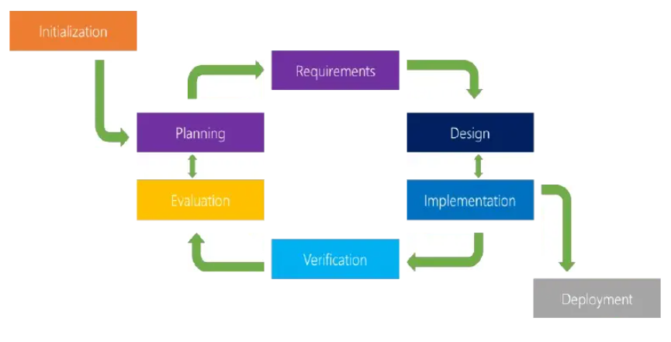

**Phases to be covered in iterative model for Restaurant Management System:**

**Planning & Requirements:**

As with most any development project, the first step is go through an initial planning stage to map out the specification documents, establish software or hardware requirements, and generally prepare for the upcoming stages of the cycle.

**Analysis & Design:**

Once planning is complete, an analysis is performed to nail down the appropriate business logic, database models, and the like that will be required at this stage in the project. The design stage also occurs here, establishing any technical requirements(languages, data layers, services, etc) that will be utilized in order to meet the needs of the analysis stage.

**Implementation:**

With the planning and analysis out of the way, the actual implementation and coding process can now begin. All planning, specification, and design docs up to this point are coded and implemented into this initial iteration of the project.

**Testing:**

Once this current build iteration has been coded and implemented, the next step is to go through a series of testing procedures to identify and locate any potential bugs or issues that have cropped up.

**Evaluation:**

Once all prior stages have been completed, it is time for a thorough evaluationof development up to this stage. This allows the entire team, as well as clients or other outside parties, to examine where the project is at, where it needs to be, what can or should change, and so on

**2.2 System Requirement Specification:**

**Data Flow Diagram:**

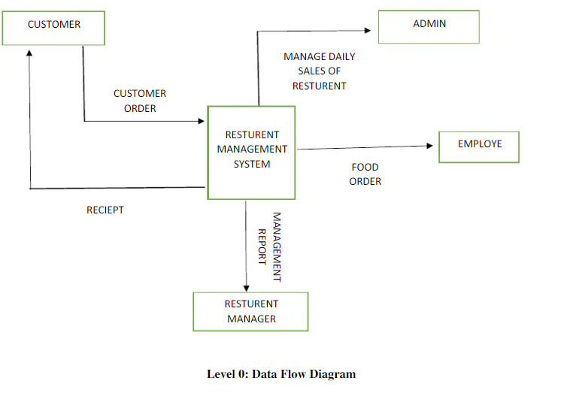

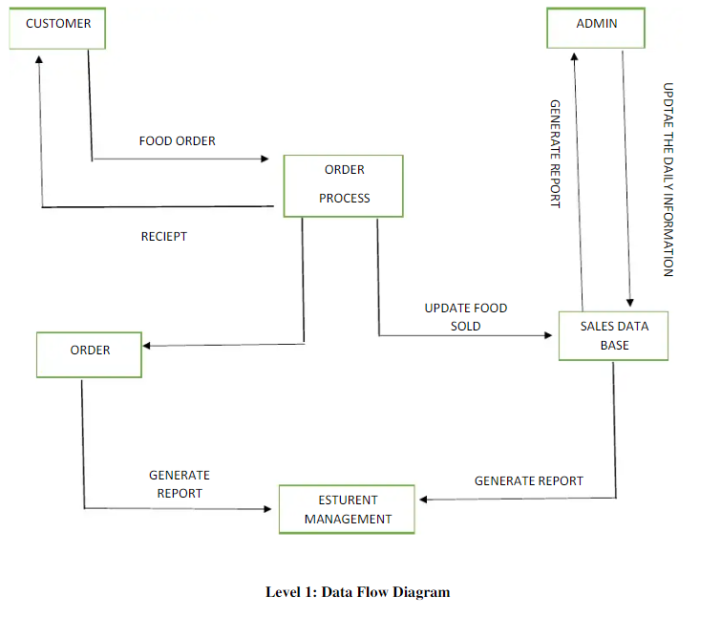

**Sequence Diagram:**

Admin site

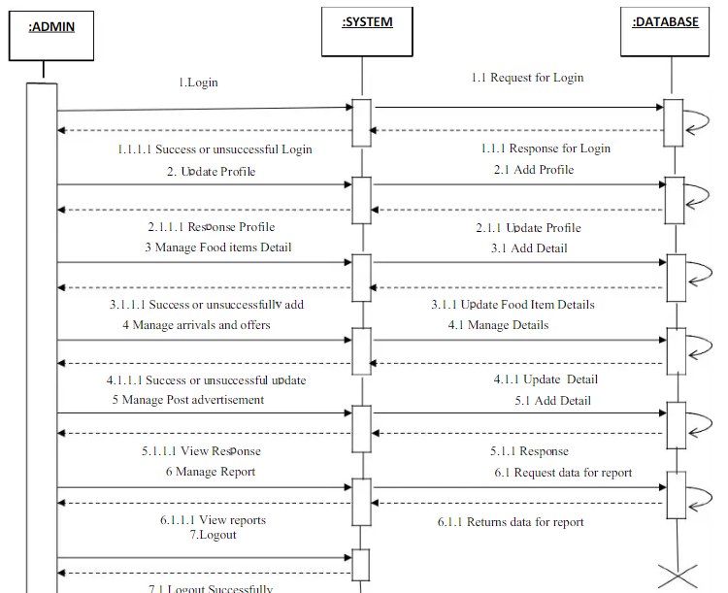

**Chapter 3**

**Performance Evaluation**

**3.1 Simulation Environment**

**Hardware Requirement:**

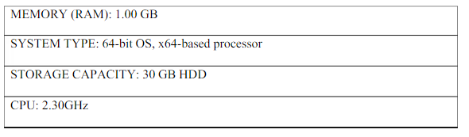

**Software Requirement:**

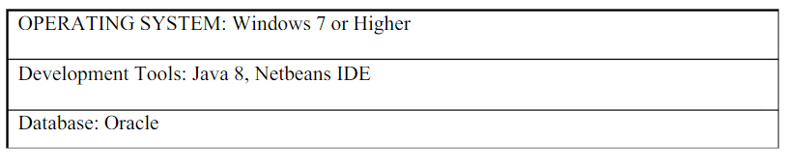

**3.2 Results and Discussions**

**Results:**

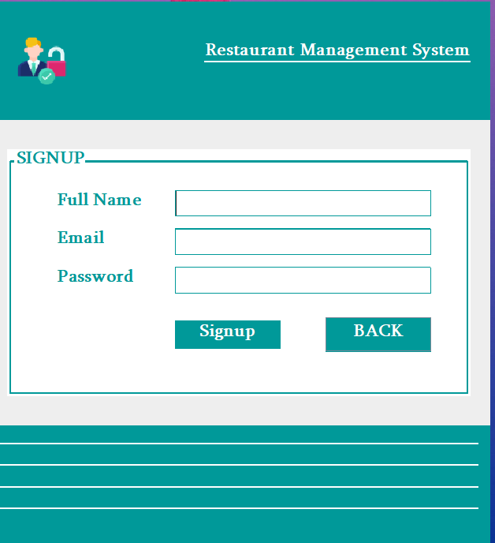

Figure 1

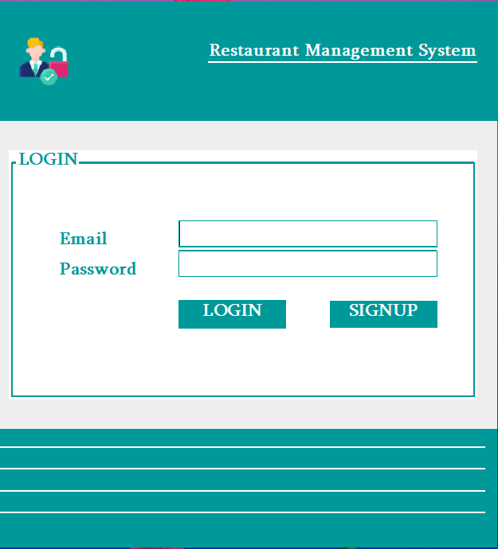

Figure 2

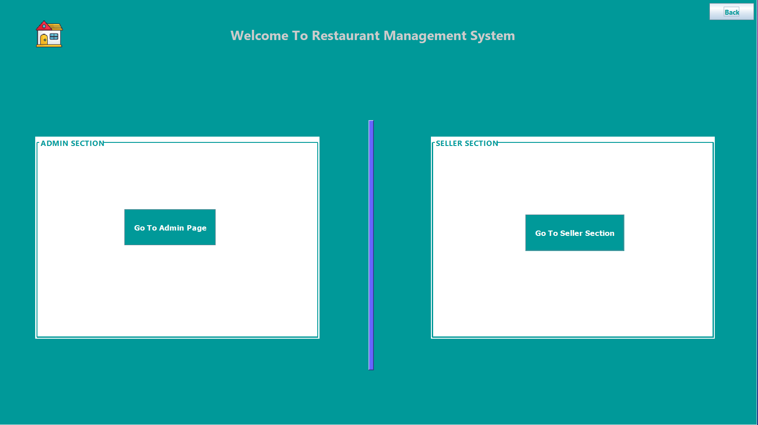

Figure 3

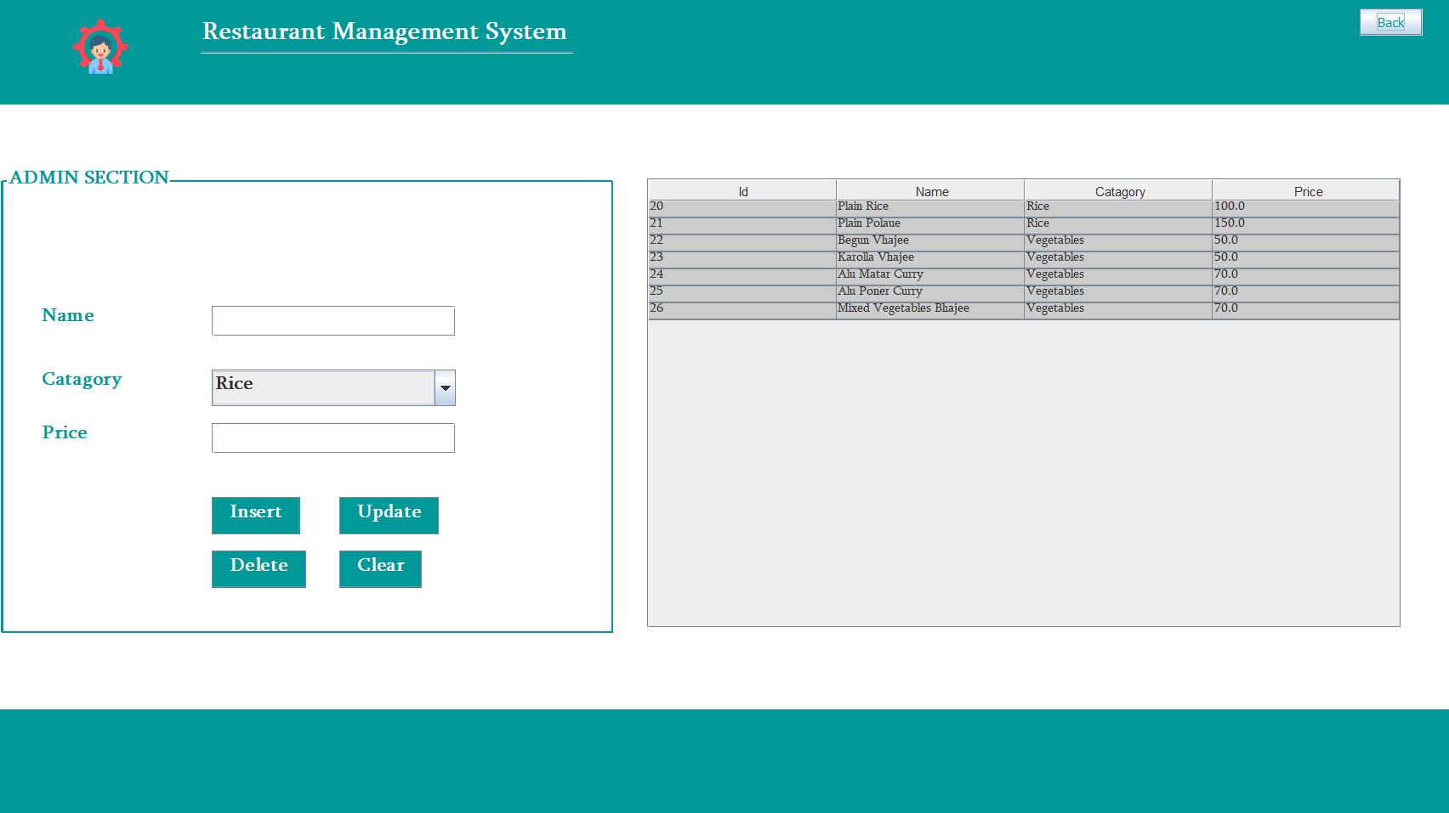

Figure 4

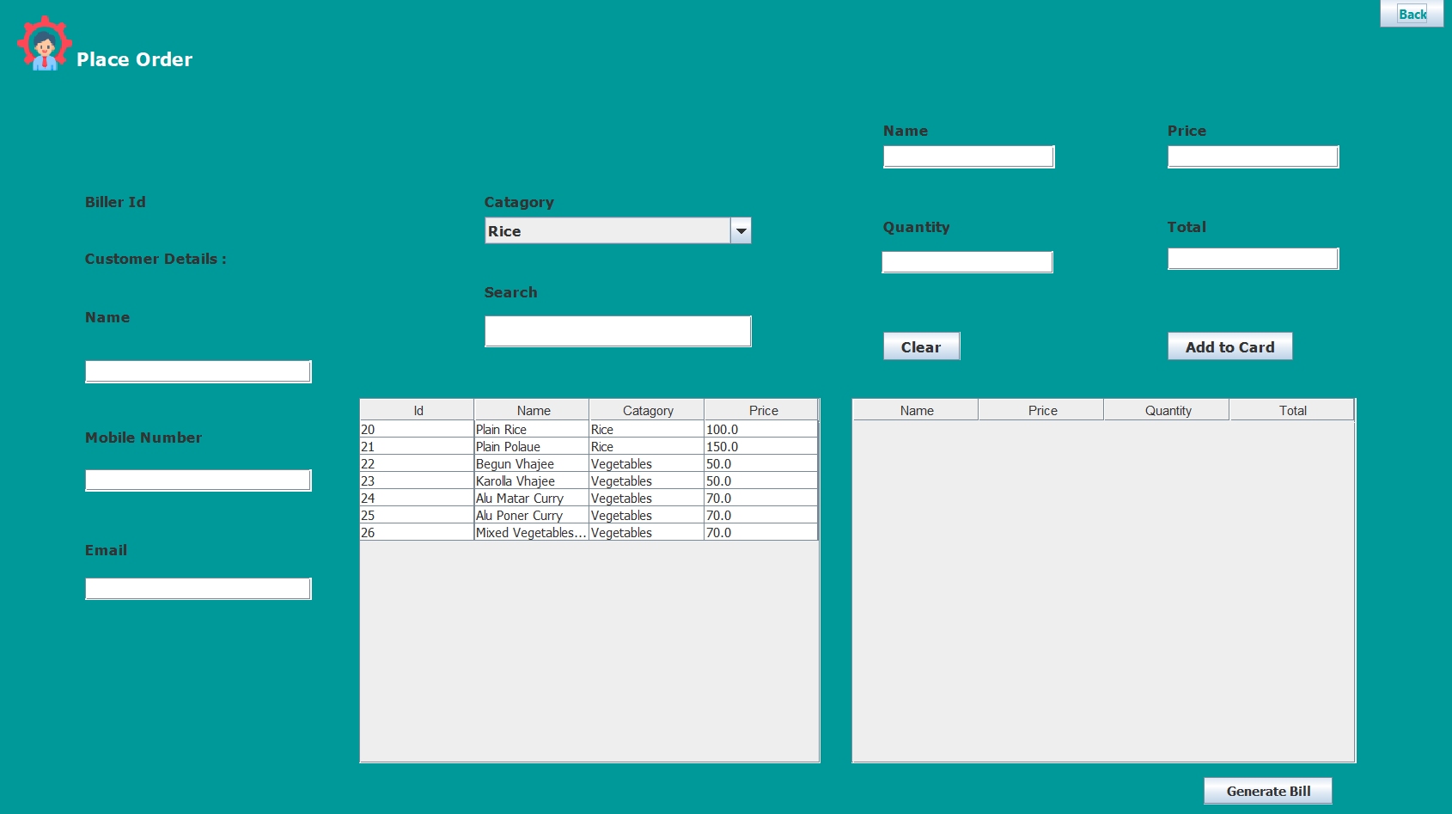

Figure 5

**Discussions:**

**Functional Description:**

* **ORDER:**

User can give order online with cash on delivery option. Restaurant manager can get the notification via sms of placed orders

* **FOOD ITEMS:**

Admin will manage the food items and their categories with prize.

Visitor or registered user can view or select the food item

**Limitations:**

* **Limitations of periodic system:**

With the periodic system, the company knows the inventory level with certainty only when it physically counts the inventory at the end of each period. Throughout the period, the companytakes customer orders without knowing the exact inventory count or whether enough products are available to meet customer demand.

* **Limited connection:**

The system limits human interaction. In this system, they are only limited to software access and maintenance and interaction amongst themselves as it is an offline management system. Offline ventures lease or build facilities for their customers, while e-commerce websites are global storefronts for online companies.

**Chapter 4**

**Conclusion**

**4.1 Introduction**

We were able to create a computerized system for Silk Route to maintain billing & Restaurant records .This system is able to store billing records securely and retrieve the records whenever needed easily. Data entering of customers and employees are also included in this system along with the order and the billing process. Customers, restaurant records and employees are interconnected in order to maintain the accuracy of this system .This system can also be further improved adding many other features and including the other systems as well. Finally we believe that we were able to launch an effective computerized system to the restaurant causing the restaurant to perform well in the future regarding the billing and restaurant records.

**4.2 Scope of Future Work**

* Generate bill and print the bill
* Enhanced and Rich UI will be Designed.
* Special Offer will be implemented.
* Another payment option will be included.
* User will get a Discount of 30% in an order of Rs 300 or above.

**References**

During the development of our system, we have taken the reference from Books and journals, which we would like to mention in this section.

These books acted as our tutors during the system development

These Books acted as our tutor during the system development

Book Name: Java The Complete Reference

Author: Herbert Schidt.

Publisher: Oracle Press.

Edition: 10th

Besides this I am referring the online manuals from the sites,

<http://www.oracle-dba-online.com/sql/oracle_sql_tutorial.htm>

<https://html.scribdassets.com/98u7q3oznk6wiqts/images/36-6074217608.png>

******Thank You******